# Media Analysis - ChatGPT

## Short Summary

The article examines rapid adoption of ChatGPT, a large language AI model, noting its integration into society but also cautioning on limitations and potential pitfalls compared to human cognition in complex reasoning tasks.

## Summary

1. **Rapid Adoption of ChatGPT**: The platform had a million unique users within five days of its release, demonstrating the unprecedented speed of AI technology adoption.  
   
2. **Predictive Power of ChatGPT**: OpenAI's algorithm uses large data sets to make guesses about trends in user behavior, indicating that human behavior is perceived as predictable by this system.  
3. **Limitations of Current AI Technology**: Despite the rapid adoption, ChatGPT lacks accurate intelligence and reasoning capabilities, unlike the human mind which can develop thoughts and language from limited data.  
4. **Ethical Concerns with AI Development**: The quick embrace of AI tools like ChatGPT raises ethical issues such as reinforcing ideologies, worldviews, truths, and untruths, potentially locking them in.  
5. **Inability to Balance Creativity and Constraint**: ChatGPT is unable to balance creative outputs with constraints, either overgenerating or undergenerating content that endorses ethical and unethical decisions alike.  
6. **Beneficial but Not Replacing Human Intelligence**: AI tools like ChatGPT can augment human intelligence by facilitating more efficient work in various domains, but they cannot replace the uniqueness of human cognition.  
7. **Incremental Incorporation Over Rapid Change**: Companies and governments should implement AI technologies incrementally rather than abruptly restructuring their working models to leverage the benefits while preserving essential aspects of human intelligence and work nature.

## Question 1:

How do the media in this article frame the public discussion about ChatGPT? Are there certain **metaphors** that keep cropping up?

The media in this article frames the public discussion about ChatGPT by using metaphors that highlight both its potential power explosion of usage and limitations babies learning from small data cues , comparing it to human cognition, and cautioning against misuse while emphasizing its predictable yet limited intelligence.

## Question 2:

Which role does or might the Arabic World play in the development of Artificial Intelligence? Answer with 'Not mentioned' if not applicable.

Not mentioned

## Question 3:

Which use cases of Artificial Intelligence are helpful for the Arabic world based on this article?

1 Predictive Analysis and Content Generation through tools like ChatGPT , 2 Ethical Considerations in AI Development, 3 Balancing Creativity with Constraint, 4 Incremental AI Integration

## Question 4:

What is the final message of the article that the author wants to convey? Keep your answer short and precise!

The final message is to encourage a balanced, ethical approach to AI integration that leverages ChatGPT's capabilities while respecting the unique human intelligence.

## Sentiment

The sentiment is 0

## Entities

Unique User Ve Day, White Paper Launch, Openai Approach Chatgpt Notion Human Behavior Predictable Analyze Large Datum, Joseph Dana Predictable Ai Tool Lack Fundamental Ability, Chatgpt Ai, Microsoft, Miss Vital Point Human Development Impact Society Ethical Issue, Https Microsoft Ethic Society Responsible Ai Layo S Entire Ai Ethic Team, Ed Language Development Vital Understand Limitation Chatgpt Come Mimic Human Thought Unlike, Noam Chomsky, Future Contestation Ection Improvement Scary Stu, Exponential View Weekly Newsletter Technology Impact Society, Serendipitously Stumble Book Know, New York Times, Joseph Dana

## Topic Clusters

### Cluster: ChatGPT and AI's Impact on Journalism

AI-generated news articles, potential job displacement, changes in journalistic ethics

### Cluster: Arab Perspective on AI and ChatGPT

AI adoption in Arabic media landscape, societal concerns about AI, regional regulations for AI use

### Cluster: AI's Role in Shaping Public Opinion

AI-driven misinformation spreading, social media influence on public discourse, AI as an opinion shaper

### Cluster: Ethical Implications of ChatGPT and AI

privacy concerns with AI data usage, accountability for AI decisions, potential biases in AI algorithms

### Cluster: Arabic AI Research and Development

investment in AI research, local AI startups and collaborations, AI policy considerations

## Word Clouds

### Wordcloud of content

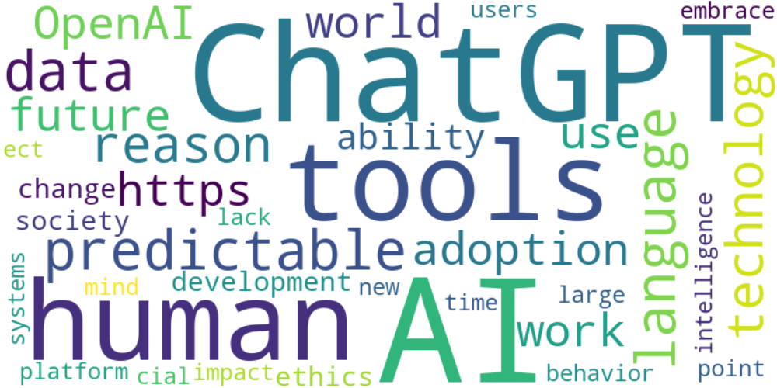

Top 10 words:

- AI: 15

- ChatGPT: 13

- tools: 8

- human: 8

- predictable: 6

- language: 6

- data: 6

- technology: 5

- reason: 5

- adoption: 4

### Wordcloud of summary

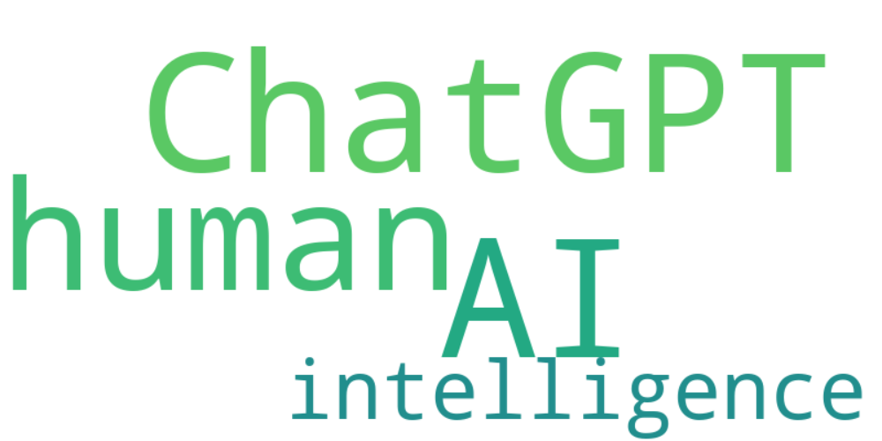

Top 10 words:

- ChatGPT: 6

- AI: 6

- human: 5

- intelligence: 3